**ICS 414 Check-In 3**

**Team Bobal:**

-Samuel Kim

-Christopher Rodrigues

-John Rasay

For this check-in we focus on writing a better drawing module for the gnomon and the dial.

The original drawing module had problems drawing the lines correctly and so we decided to use John’s drawing module from the previous semester.

In the original, both drawing the gnomon and the dial is done through using one class. The new way is done in two different classes, a class that draws the gnomon and another class that draws the dial.

In the new version of John’s class, it has 193 lines of code in the class for drawing the dial while the old version from the previous 314 project had 878 lines of code. The new version now uses a for loop in drawing the hour lines and labels and the constructor takes in an array of the angles, and labels. The gnomon class is the same from the previous version.

In the previous version of our project, we had 903 lines of code. After swapping the original drawing module with John’s drawing module, our project has a total of 948 lines of code.

As a team we spent a total of 4 hours working on this implementation. The part that took up the most time was figuring out how to make John’s drawing module work with our group’s sundial generator.

To test our program, we created a separate main program using values used in the original drawing module and used it on the new module that was taken from John’s sundial program and which is modified in the program we are using now. Check for correctness of the line being drawn was done by hand.

For future check-ins we are thinking of trying to implement a file menu where the user could save and print the file from. And also being able to resize the sundial to an 8.5 by 11 paper.

We will try to make the UI of the dial and gnomon more responsive, meaning when the user resizes the window the picture should be resized based on the size of the window frame. We will also try to have both the gnomon and dial in one window, maybe using tabs for the different pictures.

**SCREENSHOT**

**ORIGINAL:**

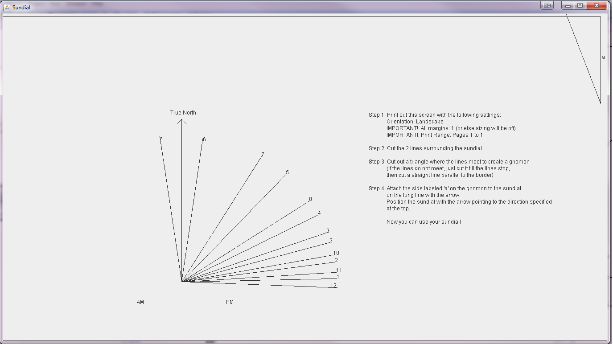

**NEW:**